

Spring 2026

Name: Adil Khan
Roll no: 2610-4011
Degree: BS AI
Task no 1:
#include <iostream>
#include <string>
using namespace std;

template <typename T>
T findMax(T a, T b) {
return (a > b) ? a : b;
}

int main() {
int int1 = 3, int2 = 7;
cout << "Max of " << int1 << " and " << int2 << " is: "
<< findMax(int1, int2) << endl;

double d1 = 4.5, d2 = 2.3;
cout << "Max of " << d1 << " and " << d2 << " is: "
<< findMax(d1, d2) << endl;

string s1 = "apple", s2 = "banana";
cout << "Max of \"" << s1 << "\" and \"" << s2 << "\" is: "
<< findMax(s1, s2) << endl;

return 0;
}

Output:
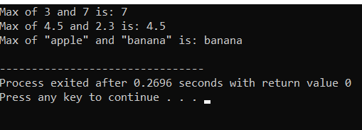

Task no 2:
#include <iostream>
using namespace std;

template <typename T>
class Circle {
T radius;

public:
Circle(T r) {
radius = r;
}

double getArea() {
return 3.14159 * radius * radius;
}

double getCircumference() {
return 2 * 3.14159 * radius;
}
};

int main() {
Circle<int> c1(5);
cout << "Circle with int radius 5:" << endl;
cout << "Area: " << c1.getArea() << endl;
cout << "Circumference: " << c1.getCircumference() << endl;

Circle<double> c2(5.5);
cout << "Circle with double radius 5.5:" << endl;
cout << "Area: " << c2.getArea() << endl;
cout << "Circumference: " << c2.getCircumference() << endl;

return 0;
}

Output:
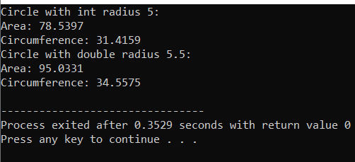

Task no 3:
#include <iostream>
using namespace std;

template <typename T>
class Calculator {
public:
T add(T a, T b) { return a + b; }
T subtract(T a, T b) { return a - b; }
T multiply(T a, T b) { return a * b; }
T divide(T a, T b) { return a / b; }
};

int main() {
int type, choice;

cout << "Select Data Type:\n1. Integer\n2. Floating Point\nChoice: ";
cin >> type;

cout << "\nSelect Operation:\n1. Add\n2. Subtract\n3. Multiply\n4. Divide\nChoice: ";
cin >> choice;

if (type == 1) {
int a, b;
Calculator<int> calc;

cout << "Enter two integers: ";
cin >> a >> b;

if (choice == 1) cout << "Result: " << calc.add(a, b);
else if (choice == 2) cout << "Result: " << calc.subtract(a, b);
else if (choice == 3) cout << "Result: " << calc.multiply(a, b);
else if (choice == 4) {
if (b != 0)
cout << "Result: " << calc.divide(a, b);
else
cout << "Error: Division by zero!";
}
}
else if (type == 2) {
double a, b;
Calculator<double> calc;

cout << "Enter two numbers: ";
cin >> a >> b;

if (choice == 1) cout << "Result: " << calc.add(a, b);
else if (choice == 2) cout << "Result: " << calc.subtract(a, b);
else if (choice == 3) cout << "Result: " << calc.multiply(a, b);
else if (choice == 4) {
if (b != 0)
cout << "Result: " << calc.divide(a, b);
else
cout << "Error: Division by zero!";
}
}
else {
cout << "Invalid data type selection!";
}

return 0;
}

Output:
